WEEK 12
Class Diagrams for Each Pattern Diagram

Singleton pattern Class Diagram – Abigeil Zenelaj
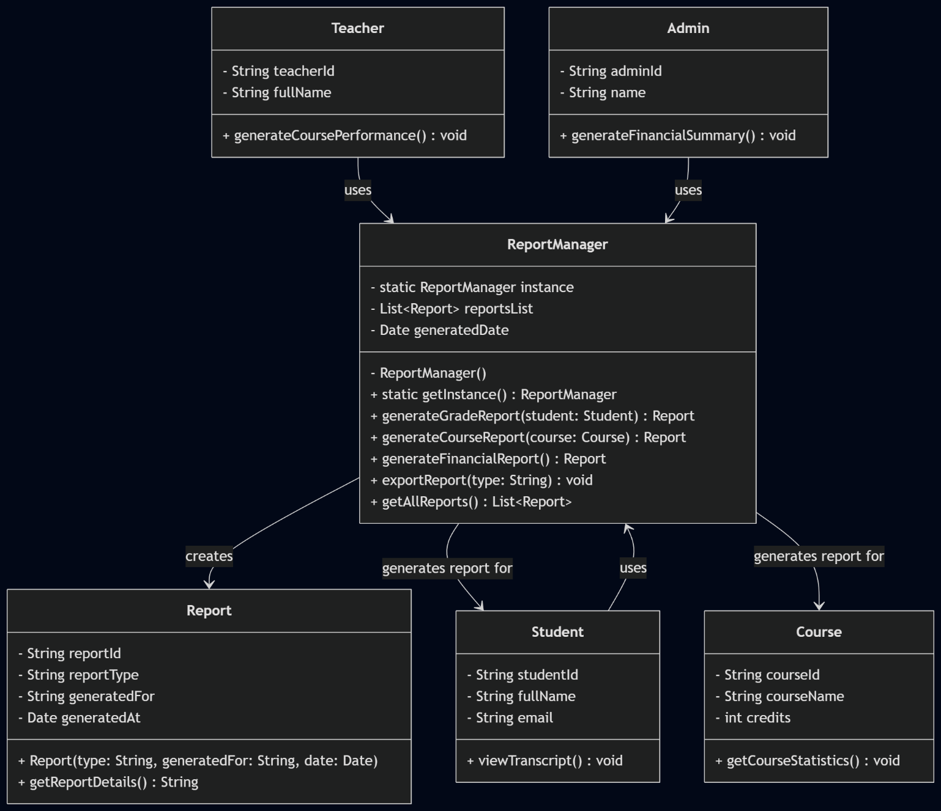

Fassade Pattern Class Diagram – Joana Taraj
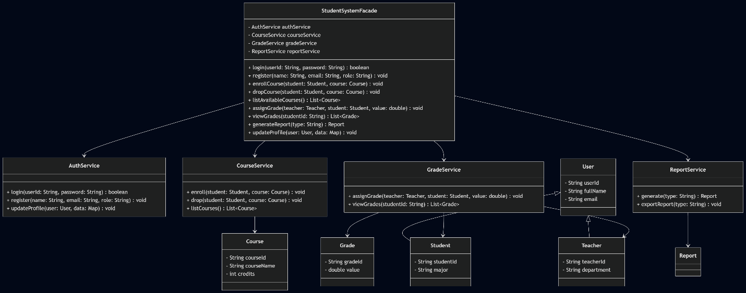

Observer Pattern Class Diagram – Sibora Hysenaj
